Product Requirements Document (PRD)
Project Title: Small Business - Broker Underwriting Interaction Agent
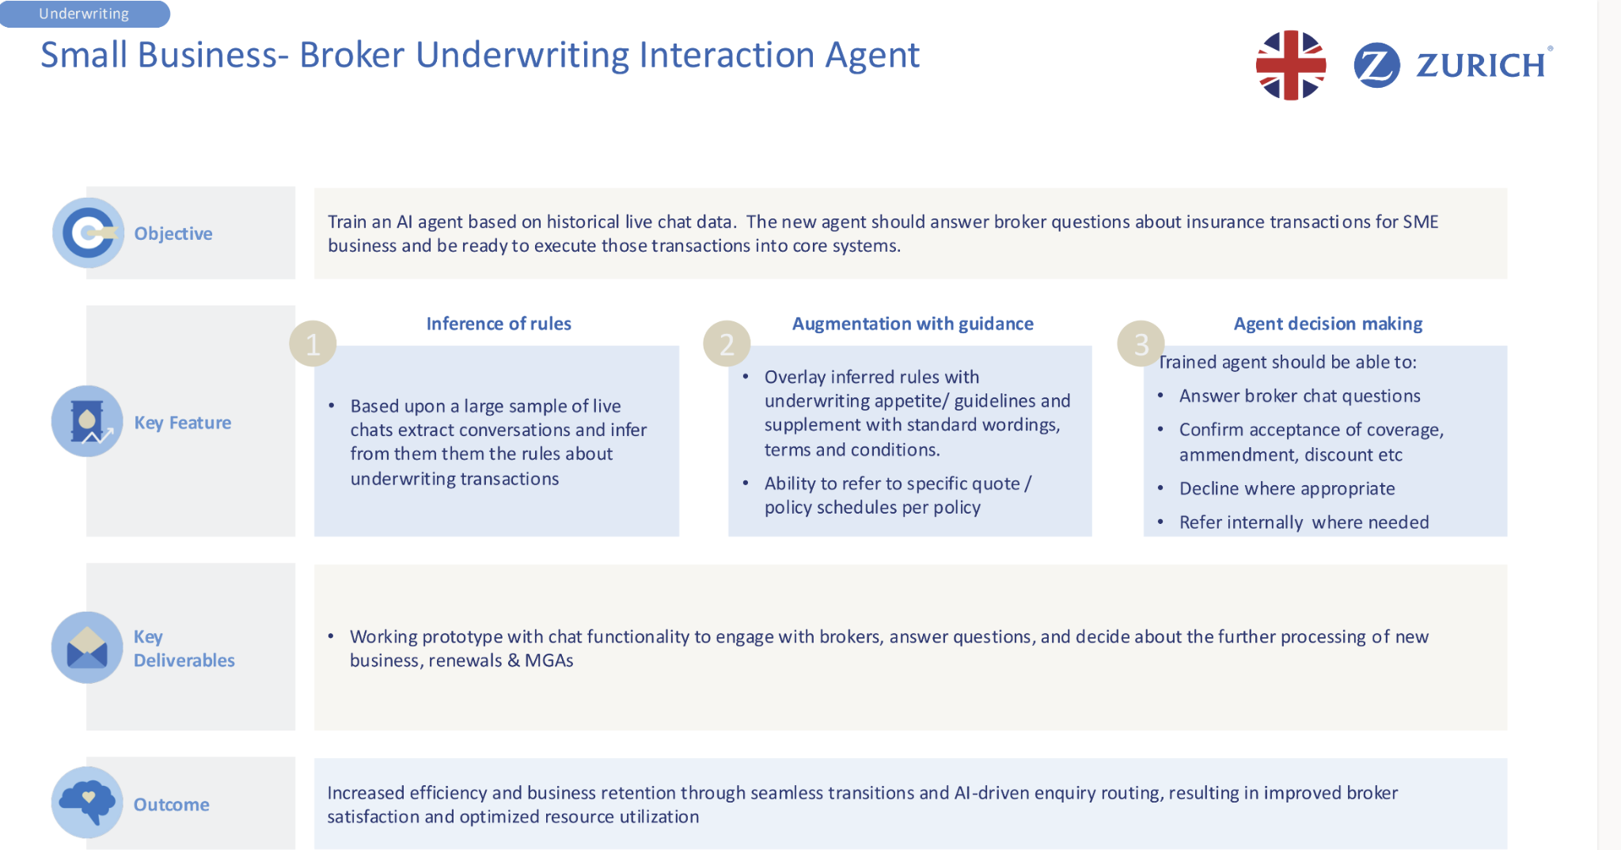

Background

🔑 Key Roles Explained

👤 Broker
Who they are: Independent professionals or firms who help clients shop for insurance from multiple insurance providers, including Zurich.
What they do:
- Represents the customer (usually a small business).
- Gathers client information, submits quote requests, asks for endorsements, or initiates changes.
- Communicates with Zurich’s underwriters (or underwriting support teams) to get approvals, clarify guidelines, or negotiate terms.
- Channels: Often via chat, email, or phone depending on urgency and preference.

👨‍💼 Human Underwriter
Who they are: Zurich employees who review and approve underwriting decisions.
What they do:
- Handle complex or unclear broker requests
- Make judgment calls beyond rule-based automation
- Ensure regulatory compliance and handle exceptions

🤖 AI Agent (Virtual Assistant)
Who it is: An AI-powered chatbot trained on Zurich’s historical chat data and underwriting rules.
What it does:
- Answers broker questions instantly via chat/email
- Accesses Zurich’s systems for quotes, policies, and terms
- Simulates underwriting decisions (e.g., apply discounts, approve changes)
- Escalates complex cases to a human underwriter
🧩 Visual Flow
🔸 As-Is Flow:  Broker 🧑‍💼  → Human Underwriter 👨‍💼  → Zurich Systems 🏢  ← Human Underwriter  ← Broker | 🔹 To-Be Flow:  Broker 🧑‍💼  → AI Agent 🤖  → Zurich Systems 🏢  ← AI Agent  ← Broker

🧾 Scenario: Broker Requests a 5% Renewal Discount
A broker wants to apply a 5% discount for a client renewing their small business insurance policy.

👨‍💼 Human Underwriter Example (As-Is Flow)
- Broker (via email or phone):
“Can I apply a 5% renewal discount for ABC Bakery?”
- Human Underwriter:
  - Reviews the email/chat manually
  - Logs into Zurich’s system
  - Searches policy, claim history, renewal terms
  - Refers to internal underwriting manual
- Underwriter emails/chat back after hours or days:
“Yes, based on the client’s clean claim history and renewal status, the 5% discount is allowed.”
- Broker:
Applies the discount and replies to the client.
- Underwriter:
Manually updates internal notes or flags the discount for processing.
🕒 Time taken: Hours days or more
⚠️ Outcome: Accurate, but slow and resource-heavy.

🤖 AI Agent Example (To-Be Flow)
- Broker (via chat):
“Can I apply a 5% renewal discount for ABC Bakery?”
- AI Agent:
  - Instantly checks:
    - Policy renewal status
    - Claims history (no claims in 3 years)
Applicable underwriting rules
  - Matches conditions:
    - "Clients with no claims for 3+ years are eligible for 5% renewal discount"
- AI Agent replies:
“Yes, ABC Bakery is eligible for the 5% renewal discount.”
- Broker:
Applies the discount and sends the updated quote to the client.
- AI Agent:
Logs the update in Zurich’s system automatically.
No human involvement needed.
✅ Time taken: ~15 seconds
✅ Outcome: Fast, accurate, and scalable.

📊 Summary
Aspect | AI Agent 🤖 | Human Underwriter 👨‍💼
Speed | Instant (seconds) | Delayed (hours/days)
Consistency | Rule-based, consistent | Depends on individual review
Scalability | High | Limited by staff availability
Human judgment | Limited (rule-driven only) | Can handle grey areas
Escalation handling | Yes, escalates unclear cases | N/A

1. Executive Summary
This project aims to develop an AI-powered underwriting assistant for small business broker interactions. By leveraging historical live chat data, the AI agent will infer underwriting rules, provide guided responses based on Zurich's policies, and autonomously handle underwriting decisions, enhancing broker support and operational efficiency.

2. Objectives
- Train an AI agent using live broker chat history to infer underwriting rules.
- Enhance agent decisions with Zurich underwriting guidelines, wordings, and policy documents.
- Enable the agent to execute underwriting decisions or escalate appropriately.

3. Scope and Use Cases
In-Scope:
- Broker chat understanding and real-time response.
- Automation of underwriting-related transactions.
- Escalation and routing logic.
Use Cases:
- Broker inquiries on policy coverage, amendments, or discounts.
- Confirmation or denial of underwriting requests.
- Internal referral for exceptions or escalated queries.

4. Key Features
- Inference of Rules
  - Analyze historical chat logs.
  - Extract conversational patterns to infer underwriting logic.
- Augmentation with Guidance
  - Integrate Zurich appetite guidelines.
  - Use standard terms, policy schedules, and quote data.
- Agent Decision Making
  - Respond to broker questions.
  - Confirm or decline underwriting actions.
  - Escalate when necessary.

5. Functional Requirements
- Chat ingestion pipeline and NLP model for rule extraction (we might receive chat log).
- API access to Zurich's underwriting guidelines and policy documents.(we might receipt API access or policy document or rule)
- Chat interface with decision logic and escalation triggers.

6. Technical Requirements
- Integration with Zurich’s core underwriting systems.
- Secure handling of broker and policyholder data.
- Model retraining and fine-tuning infrastructure.

7. System Architecture Overview
- Data ingestion: Historical chats (input).
- AI inference engine: NLP and classification model.
- Policy integration layer: API to Zurich policy databases.
- UI layer: Broker-facing chatbot.
- Logging and monitoring service.

8. User Interaction and UI Considerations
- Simple web-based interface or integration into broker portal.
- Clear response logs and manual override options.
- Feedback loop for corrections and learning.

9. Key Deliverables and Milestones
- May 12 – June 1: Application submission
- June 10: Onboarding call
- June 16 – 29: Hackathon Live (build prototype)
- July 7 – 20: Final presentations
- August: Winner announcement
- October: Innovation Day and pilot result announcement

10. Expected Outcomes and Success Metrics
- Reduce underwriting response time by 50%.
- Automate 60–70% of standard broker queries.
- Improve broker satisfaction (measured via post-interaction survey).

11. Risks and Mitigations
Risk | Mitigation Strategy
Misinterpretation of chat context | Human-in-the-loop review + escalation mechanism
Outdated rule inference | Regular model updates + policy synchronization
Compliance with Zurich guidelines | Strict API controls and audit logs

